

ABC Awards Photographic Identification of
Tools and Equipment – Lawn Care

These photographic identifications can be used as knowledge evidence towards units within the following qualifications:

Level 1 Award in Practical Horticulture Skills [50098548]
Level 1 Certificate in Practical Horticulture Skills [5009693X]
Level 1 Certificate in Practical Environmental and Conservation Skills [50040856]
Level 1 Award in Practical Environmental and Conservation Skills [50040868]
Level 1 Diploma in Work-Based Environmental Conservation [50075378]

Level 2 Award in Practical Horticulture Skills [50096357]
Level 2 Certificate in Practical Horticulture Skills [50096333]
Level 2 Award in Practical Environmental and Conservation Skills [50097404]
Level 2 Certificate in Practical Environmental and Conservation Skills [50097660]
Level 2 Diploma in Work-Based Horticulture [50067564]
Level 2 Diploma in Work-Based Environmental Conservation [50087058]

Level 3 Award in Practical Horticulture Skills [50096126]
Level 3 Certificate in Practical Horticulture Skills [50096345]
Level 3 Diploma in Work-Based Horticulture [50067357]
Level 3 Diploma in Work-Based Environmental Conservation [5008706X]

Learner |  | Assessor
This evidence relates to the following unit (s) |  |  | Assessment criteria reference (s)
(add rows as necessary)
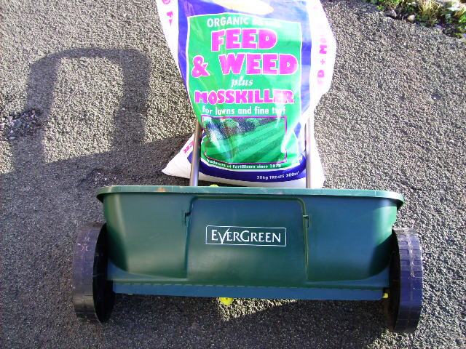  Equipment name: .........................................................  Use: ..............................................................................  ......................................................................................  Maintenance: ................................................................  ....................................................................................... |  |  | 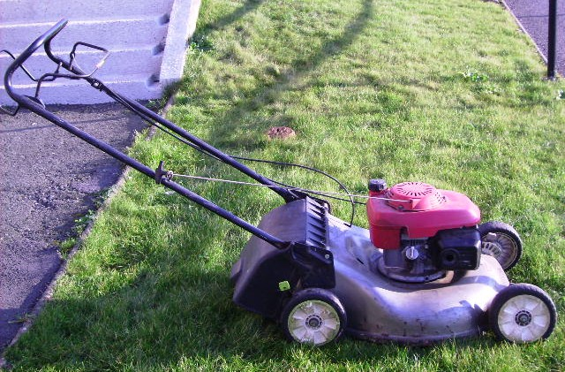  Equipment name: ........................................................  Use: ............................................................................  ....................................................................................  Maintenance: ..............................................................  .....................................................................................
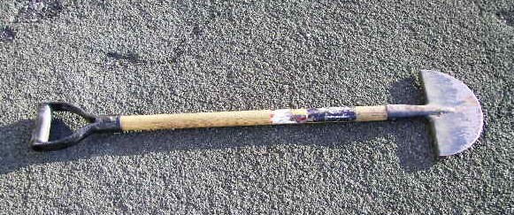  Tool name: ...................................................................  Use: ..............................................................................  ......................................................................................  Maintenance: ................................................................  ....................................................................................... |  |  | 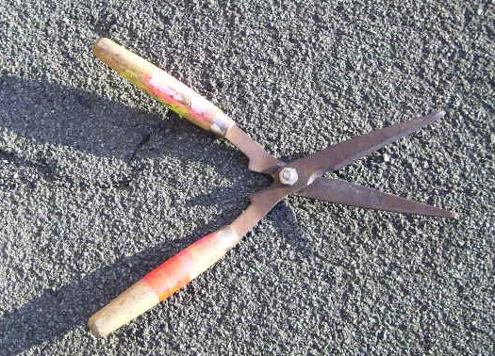  Tool name: .................................................................  Use: ............................................................................  ....................................................................................  Maintenance: ..............................................................  .....................................................................................

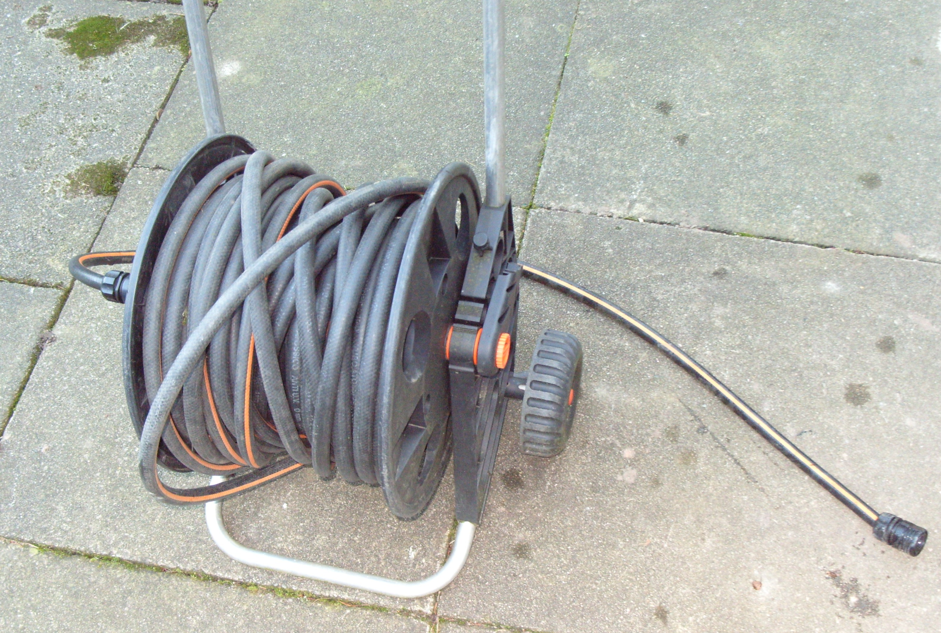  Equipment name: .........................................................  Use: ..............................................................................  ......................................................................................  Maintenance: ................................................................  ....................................................................................... |  | 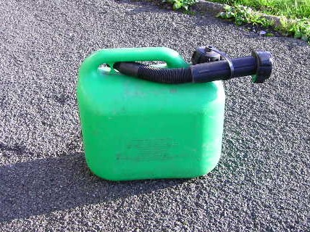  Equipment name: ........................................................  Use: ............................................................................  ....................................................................................  Maintenance: ..............................................................  .....................................................................................
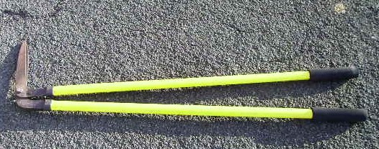  Tool name: ...................................................................  Use: ..............................................................................  ......................................................................................  Maintenance: ................................................................  ....................................................................................... |  | 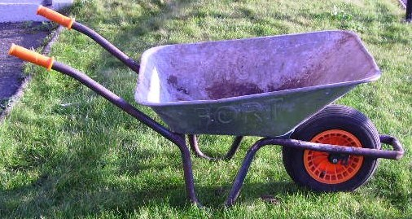  Equipment name: ........................................................  Use: ............................................................................  ....................................................................................  Maintenance: ..............................................................  .....................................................................................
Learner signature |  |  | Date
Assessor signature |  |  | Date
Internal moderator / quality assurer signature |  |  | Date

